Quarterly report of swamp kauri activity
1 July 2017 – 30 September 2017 _________________________________________________________________________

Swamp kauri, also known as ancient kauri, is kauri timber that has been buried and preserved in what used to be swamps for anywhere between 800 and 60,000 years.

The Ministry for Primary Industries (MPI) is responsible for regulating the milling and export of swamp kauri under the Forests Act 1949 (“the Act”). More information on the management of swamp kauri can be found at:
http://www.mpi.govt.nz/exporting/forest-products/wood-and-wood-products/swamp-kauri

This report summarises MPI’s regulatory activities in regard to the milling and export of swamp kauri, in the third quarter of 2017 (1 July 2017 – 30 September 2017).

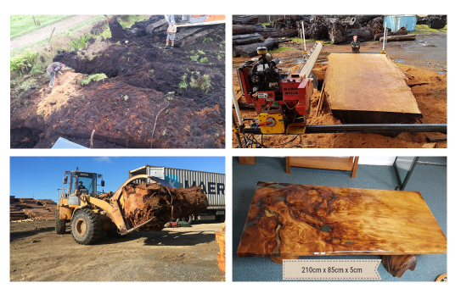

Milling controls

All indigenous timber - including swamp kauri - can only be milled by sawmills registered with MPI. MPI regularly inspects registered sawmills which are required to report their milling activity every quarter. All swamp kauri must also have an approved milling statement from MPI before it can be milled at a registered sawmill.

Table 1: Milling statements issued 1 July – 30 September 2017
Milling statement # | Timber source | Region | Volume
7-00-02755¹ | Land that is not indigenous forest land | Northland | 0.5
7-00-02758² | Land that is not indigenous forest land | Northland | 50
7-01-02776 | Land that is not indigenous forest land | Auckland | 20
 |  |  | 70.5m³

^{1.} This is a part renewal of 7-00-02285.
^{2.} This is a part renewal of timber remaining from of timber remaining from 7-00-01704; 7-00-01909; and 7-00- 01891.

Site inspections

Responsibility for managing the extraction of swamp kauri rests with Regional and District Councils, under the Resource Management Act. However, as part of the evidence required when applying for a milling statement or for export approval, MPI inspects all new notified sites before and after extraction activities.

Two extraction sites were active this quarter. One had a pre-extraction inspection conducted in a previous quarter. MPI conducted post extraction inspections of two sites which were active in previous quarters.

Table 2: Inspections of notified swamp kauri extraction sites, 1 July – 30 September 2017.
Total Sites | 4
Total Inspections | 1
Pre-extraction | 1
Mid-extraction
Post-extraction | 2

Export controls

Swamp kauri can only be exported as either a finished product or, if it isn’t from indigenous forest land, as whole or sawn stumps or roots. Indigenous timber export controls are set out in Section 67C of the Act.

Table 3: Notified swamp kauri export consignments for 1 July – 30 September 2017
Destination | Number of exports approved | Number of export inspections | Volume exported
Canada | 1 | 1 | 0.186 m³
China | 1 | 1 | 5.95 m³
Italy | 2 | 2 | 13.73 m³
Korea | 1 | 1 | 18.07 m³
Taiwan | 2 | 2 | 20.8 m³
Total | 7 | 7 | 58.74 m³

Figure 1: Swamp kauri export volumes for Quarter 3 (1 July – 30 September), 2010 – 2017.

Figure 2: Monthly swamp kauri export volumes, 2010 – 2017 (trend: three point moving average).

