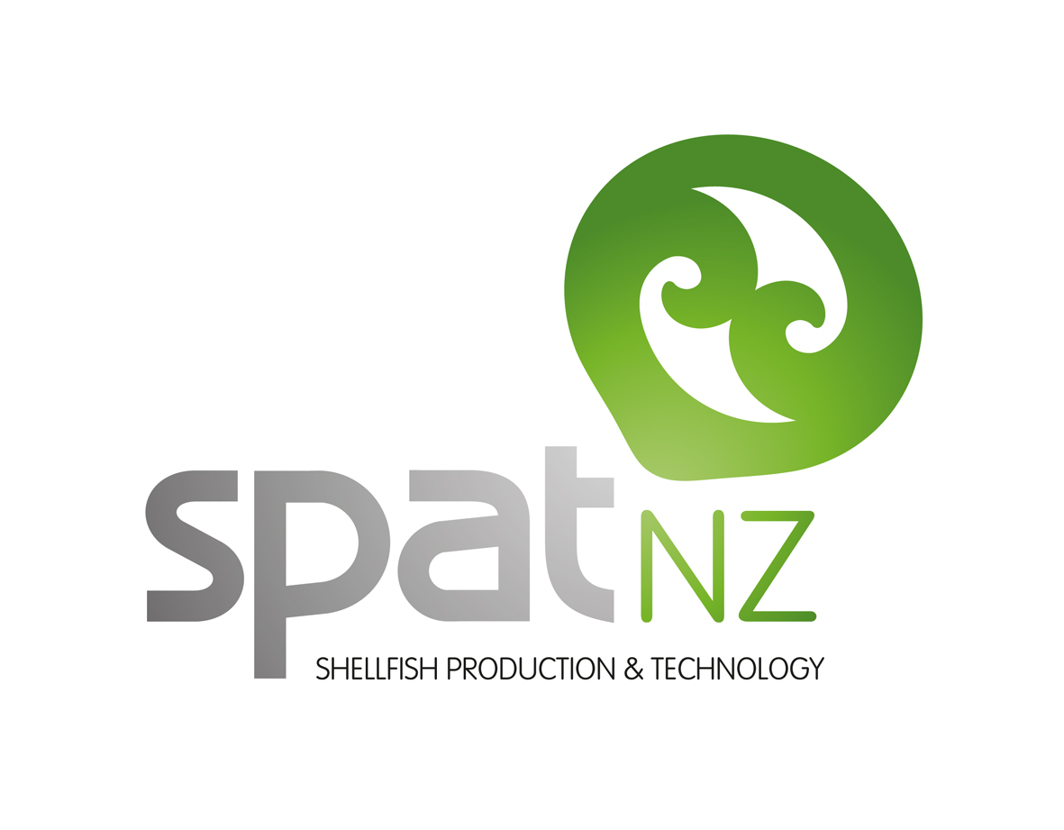
QUARTERLY PROGRESS SUMMARY: Apr to Jun 2018
SPATnz

Summary of progress during this quarter
SPATnz contributes to aquaculture training in Nelson for both secondary and tertiary students, and two of our main student events took place in the April to June quarter. Each year Cawthron Institute and the University of Otago’s Marine Studies Centre team up to offer Year 13 science students the chance to do a practical science project in an aquaculture setting. SPATnz gives each student a tour of our mussel hatchery to set the scene and show them aquaculture research in action.

Some of the students go on to study aquaculture at Nelson-Marlborough Institute of Technology (NMIT) and here SPATnz has a more direct involvement. SPATnz’s main teaching involvement is a month-long hatchery principles module, where the students rear a batch of mussels from eggs through the larval stages to settlement. It’s a 7 day a week commitment looking after the mussels, the systems, and growing the microalgae for the mussels to eat. SPATnz also hosts students for work placements, and research projects.

An independent expert review of our Greenshell™ mussel selective breeding programme conducted this quarter concluded that the programme “compares very favourably to other aquaculture breeding programs on a global scale.” ”The fundamental science and design aspects are sound, and satisfy the requirements of a modern selective breeding program.” A detailed report provided numerous practical suggestions for incremental improvements, many of which are already being acted upon.

Research on hatchery technology, spat survival and selective breeding continued.

Key highlights and achievements
- Successful completion of the hatchery training exercise where SPATnz staff help NMIT aquaculture students rear a batch of mussel larvae.
- Favourable and informative independent expert review of the selective breeding programme.
Upcoming
- Harvest assessments on the 2017 cohort of mussel families will commence
- Factory processing of hatchery and wild mussels will resume
Investment
Investment period | Industry contribution | MPI  Contribution | Total  Investment
During this Quarter | $0.31 M | $0.31 M | $0.62 M
Programme To Date | $9.74 M | $9.74 M | $19.47 M

Photo 1: A thankyou cake from marine educator Richard de Hamel following the Year 13 Science projects. Mussel embryos hatch from eggs in large incubation tanks (top left). With food from algae grown in bags (top right) the mussels grow through their larval stages in conical tanks (centre) before settling on rope in square settlement tanks (bottom left). A month later they are transferred to ropes on mussel farms at sea (bottom right).

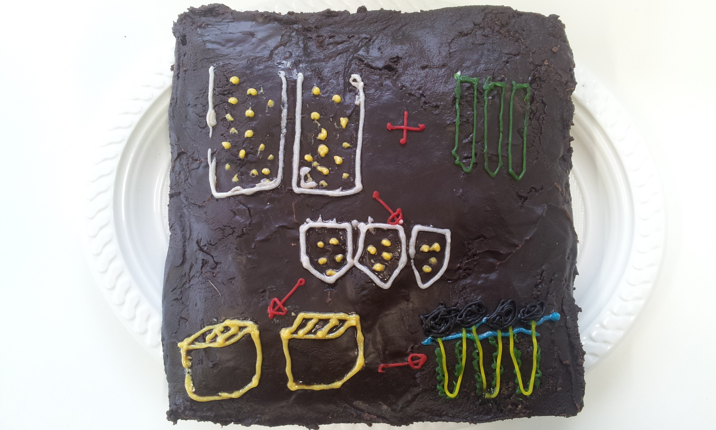

Photo 2: NMIT student Hannah Coote on work placement at SPATnz with NMIT graduate Ellie Kerrisk. Hannah is now a larval technician at SPATnz.

